**LAGRANGE INTERPOLATION**

*NAME* : **LAGRANGE-NSPIR** *v1.1*

The program returns the Lagrange interpolating polynomial of minimum degree k for a set of points (x0,y0,….., xn,yn), where 1 <= k <= n and shows the curve plus the entered points in a graph. A set of at least two points has to be entered.

The program is mainly based on the smart function “*Lagrangeinterpolation*” for the TI-89 by Paolo Silingardi ([www.ticalc.org/archives/files/fileinfo/384/38460.html](http://www.ticalc.org/archives/files/fileinfo/384/38460.html)) and has been adapted to the

TI-nspire (CX) and expanded by a graph of the entered points and the result on page 1.2

*EXECUTION:*

Transfer the program to MyLib and choose **Lagrange_nspir**, then start the program on page 1.1 by calling up ***lagrange***({x0,…xn},{y0,…,yn}). The last set of points is stored in the variables ***la_x***

(x-values) and ***la_y*** (y-values).

*EXAMPLE:*

Find the function to the set of points (0,0), (1,2), (2,0), (3,0), and (4,32).

Key “var”, choose “lagrange” and enter ***“lagrange({0,1,2,3,4},{0,2,0,0,32})”***

The result is : **x4-5*x3+6*x2** and on page 1.2 :

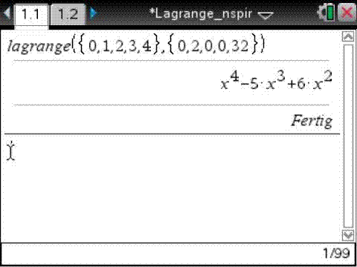 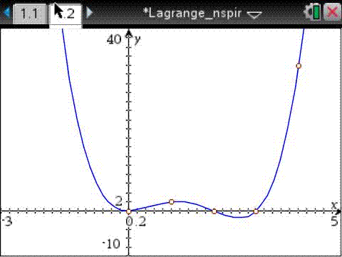

*Claus Dachselt*

*clan.dachselt@t-online.de*